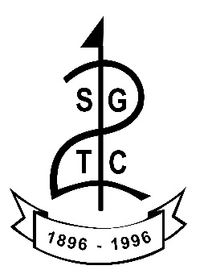

CODE OF CONDUCT FOR PARENTS/CARERS

As a parent/carer of a junior member you are expected to abide by the following code of conduct.

You should:

- Encourage your child to learn the rules and play within them.

- Discourage unfair play and arguing with club staff/officials.

- Help your child to recognise good performance and effort, not just results.

- Never force your child to take part in golf.

- Set a good example by recognising fair play and applauding good performances of all.

- Never punish or belittle a child for losing or making mistakes.

- Publicly accept officials' judgements.

- Support your child's involvement and help them to enjoy their golf.

- Use correct and proper language at all times.

- Never use threatening or abusive behavior towards children, officials, coaches or other parents.

- Always notify the Junior Organiser if you will not be attending or going to be late for a coaching session/competition.

- Ensure that coaches are made aware of any pre-existing medical conditions your child has.

- Ensure that all correspondence and consent forms are replied to by the due date.

- Ensure that your child is dropped off and picked up on time after each session.

I am aware that the Club’s Safeguarding Officer is Kirsten Nicholson and I am aware that if I have a concern or would like to talk to somebody, I can contact Scottish Golf’s Safeguarding team by email safeguarding@scottishgolf.org or by telephone 07812665164
I have read and understood this Code of Conduct and I agree to abide by the rules and guidelines of the Club.

Name ……………………………………........

Signature ...…………………….…………….
Date ……...…………….

