SHISKINE GOLF & TENNIS CLUB
Blackwaterfoot  Isle of Arran  KA27 8HA | 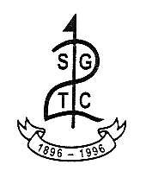 | Tel: 01770 860 548  Email: info@shiskinegolf.com  Web: www.shiskinegolf.com  Club Manager: Kirsten Nicholson

JUNIOR MEMBERSHIP APPLICATION FORM

Candidate Surname
Candidate Forename/s
Address
Postcode
Telephone No.
Mobile No.
E-Mail
Date of Birth
School attended
List of other Golf Memberships held
(if relevant)
Home Golf Club
WHS Handicap & CDH No.
Name of Parent/Legal Guardian
Address
Postcode
Phone number
Signature of Parent/Legal Guardian
Date
Signature of Parent/Legal Guardian

Office Use Only
Membership Number: Temp P/W:
Email sent: Initials:

