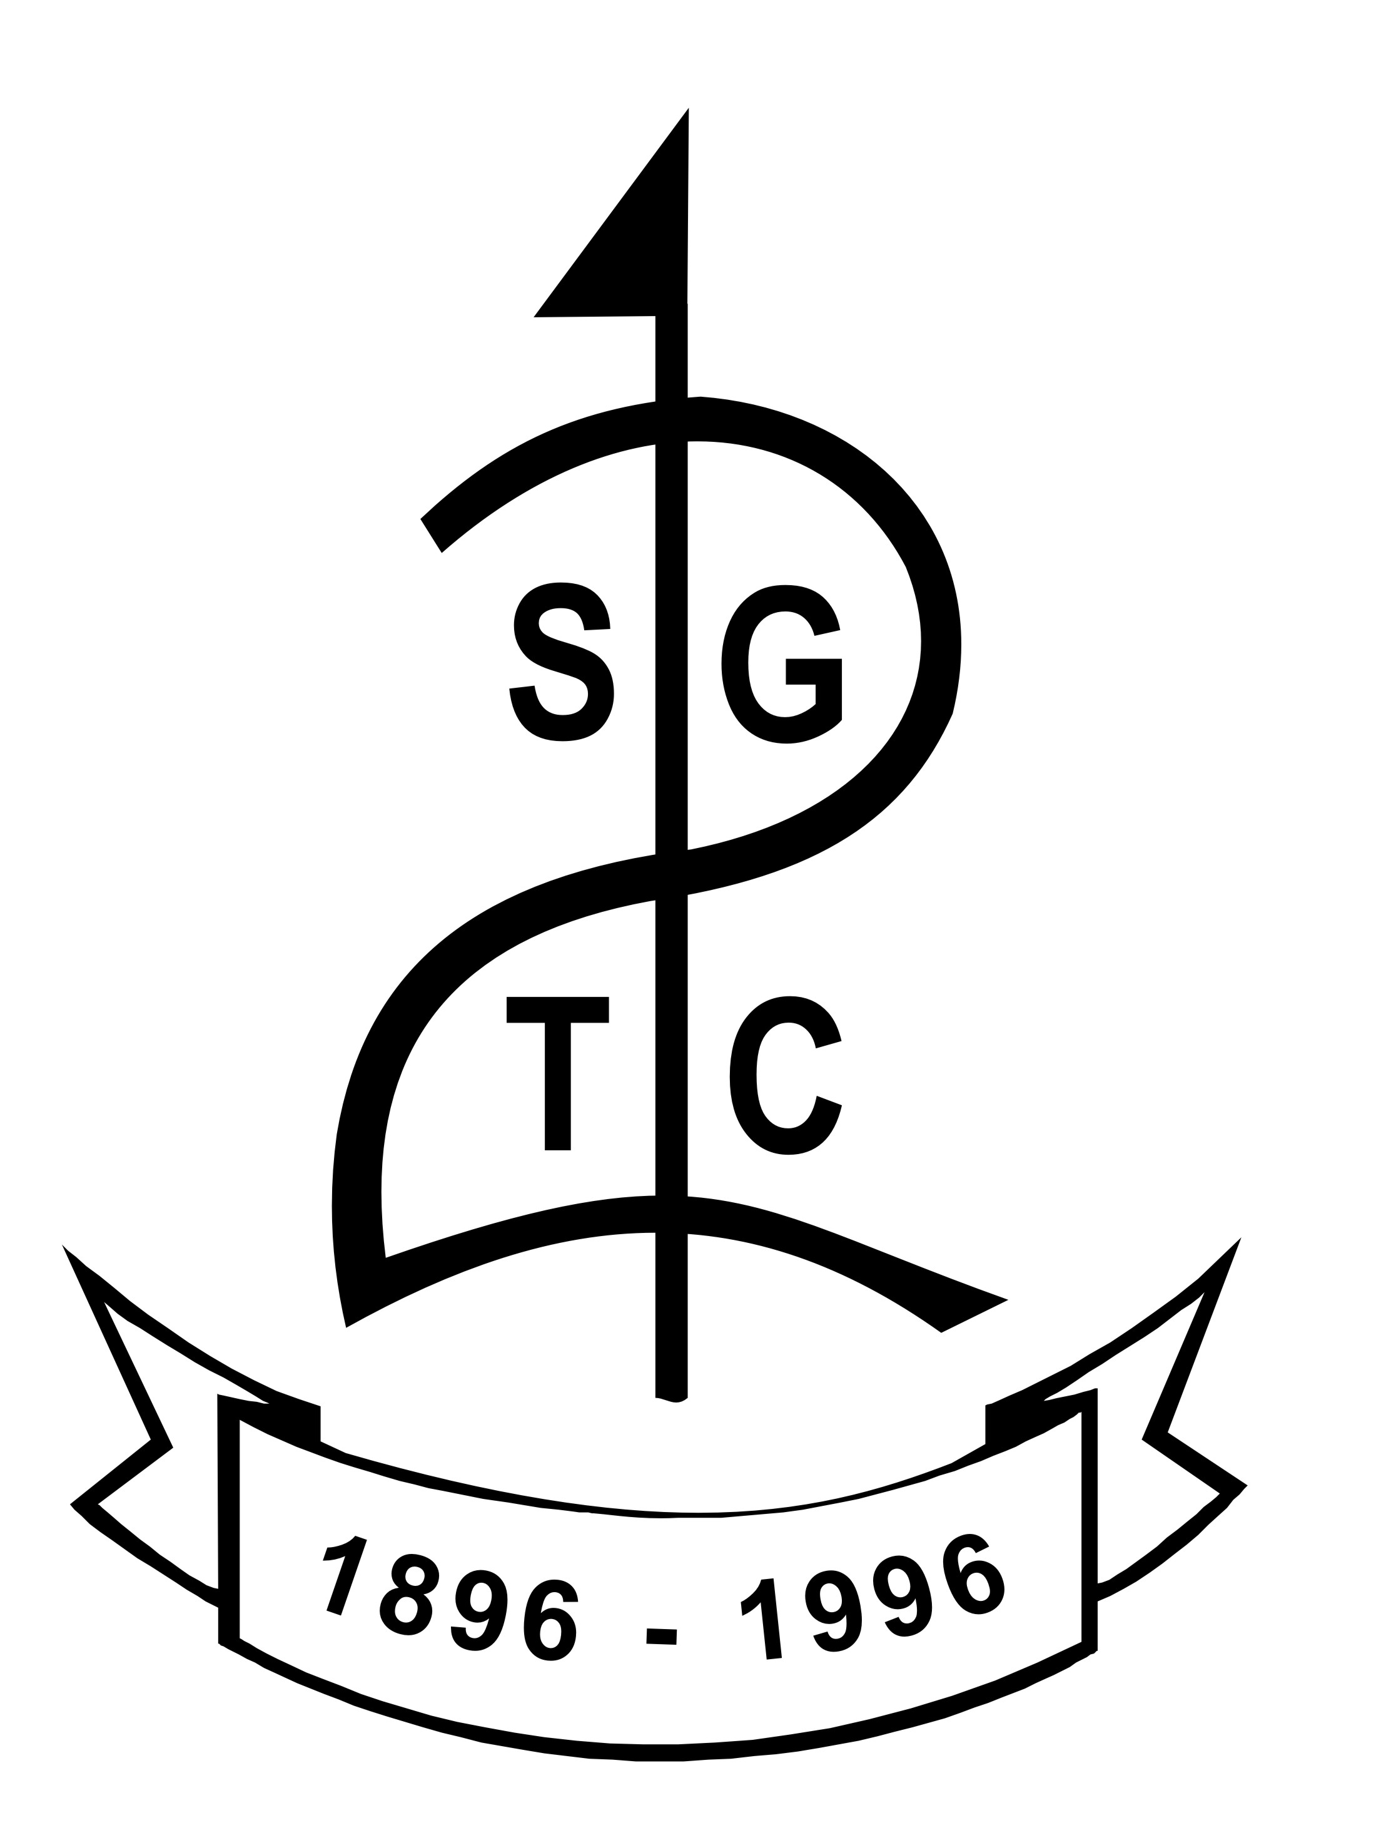

CODE OF CONDUCT FOR JUNIORS

Shiskine Golf and Tennis Club is dedicated to creating an environment that nurtures the enjoyment and enthusiasm of every member within our club. We want to empower our juniors to base their conduct on a sense of personal integrity and acceptance of rules, fairness, equality, respect for others, moral conduct and a sense of what is right.

I agree to:
- Be friendly and supportive, offer help if needed
- Practice and participate fairly and be trustworthy
- Behave with respect to others including coaches/volunteers, club staff, officials, other golfers, parents, team managers and spectators
- Respect the rules of my club and those of the facilities, for example, care of the course which includes repair of pitchmarks and divot replacement
- Respect the rights, dignity and worth of all participants regardless of age, disability, gender, ability, race, cultural background or religious beliefs or sexual identity
- Always strive to do my best and refrain from inappropriate conduct towards others including physical, verbal, written or emotional, in person or through use of social media
- Be a positive role model and refrain from bullying and getting involved in inappropriate peer pressure and push others into something they do not want to do
- Set a good example at all times in aspects of punctuality, language, behaviour and respect of equipment and others
- Be aware of speed of play and other golfers on the course
- Will not smoke, consume alcohol or drugs of any kind
- Report inappropriate behaviour or risky situations to a member of staff

Our Club recognises that to create a supportive atmosphere, which allows everyone to participate/compete to the best of their abilities, it is important for juniors to know that while we have high expectations of their behaviour, they can expect the same in return from us.

You have the right to:
- Be safe and happy while participating in golf
- Be respected and treated fairly and participate on an equal basis, appropriate to your ability
- Be protected from abuse by others from within or out with the club
- Ask for help
- Be believed
- Be listened too
- Be referred to professional help if needed

Breaches of the Juniors Code of Conduct will be dealt with in accordance with the club’s disciplinary procedures.

I understand that if I do not follow the Juniors Code of Conduct, any/all of the following actions may be taken:
- Be required to apologise formally
- Receive a warning; verbal or written
- Be suspended by the club
- Be required to leave the club

I am aware that the Club’s Safeguarding Officer is Kirsten Nicholson and I am aware that if I have a concern or would like to talk to somebody, I can contact Scottish Golf’s Safeguarding team by email safeguarding@scottishgolf.org or by telephone 07812665164

I have read and understood the above Code of Conduct and I agree to be bound by it.

