Shiskine Golf Club  Ladies Greensome Open Day | 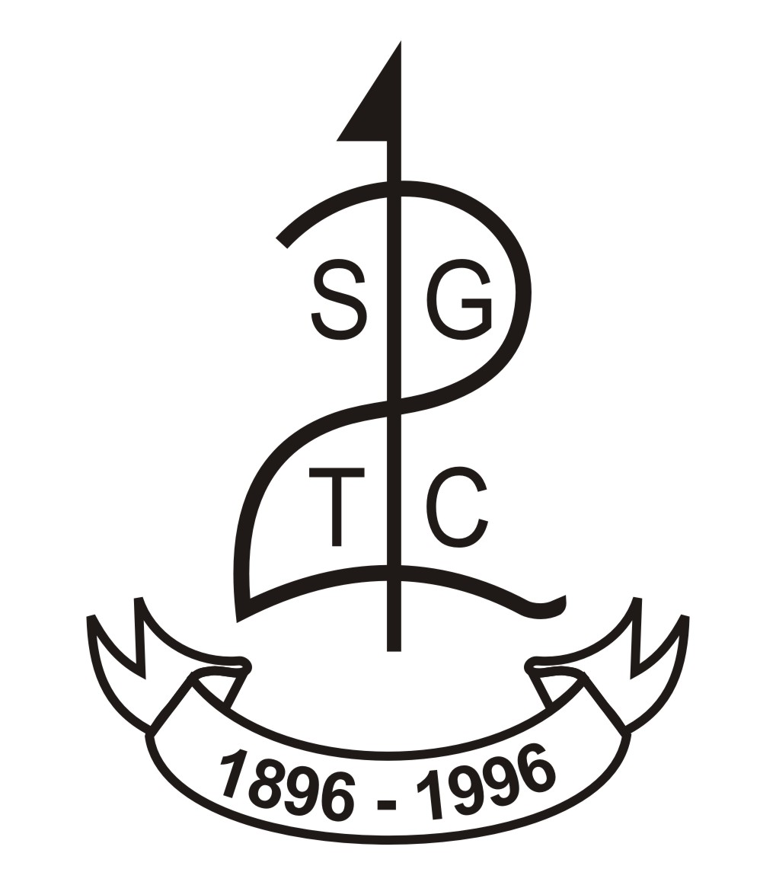
Thursday 24th July, 2025

Entry Fee £20 per pair (non-returnable)

Name: | Partner's Name:
Address: | Address:
Postcode: | Postcode:
Tel: | Tel:
E-mail | E-mail:
Home Club: | Home Club:
Handicap Index: | Handicap Index:
CDH Ref: | CDH Ref:
Starting times between 10am – 3.30pm

Please let us know your preferred starting time

Morning.............. Afternoon...............
(Preferred time will be accommodated as close as possible but no guarantees!)

Upon request confirmation will be sent by e-mail.

Please send entries to: info@shiskinegolf.com, pop in to the office,
or post your entry to: Kirsten Nicholson, Club Manager, Shiskine Golf Club,
Blackwaterfoot, Isle of Arran, KA27 8HL.

Entry Fees payable via Cash, Bacs or Debit/Credit card.

For Bacs payments – Account Name: Shiskine Golf & Tennis Club, Sort Code:800584. Account No: 00827969 (with the lead surname and ‘Ladies Open’ as the bank reference)

To pay by debit/credit card Tel: 01770 860548

