Greens Update – 2nd May 2025
This week began on a challenging note due to unfavourable weather conditions affecting our Gents Open. Heavy rain on Saturday followed by additional downpours overnight into Sunday morning led to parts of the course becoming waterlogged. Unfortunately, this prevented us from completing the planned course maintenance ahead of the Open. Nonetheless, we managed to commence the event after a delayed start at 10am. In total, we received 17mm of rainfall, with 7mm falling on Saturday and an unexpected 10mm overnight into Sunday.
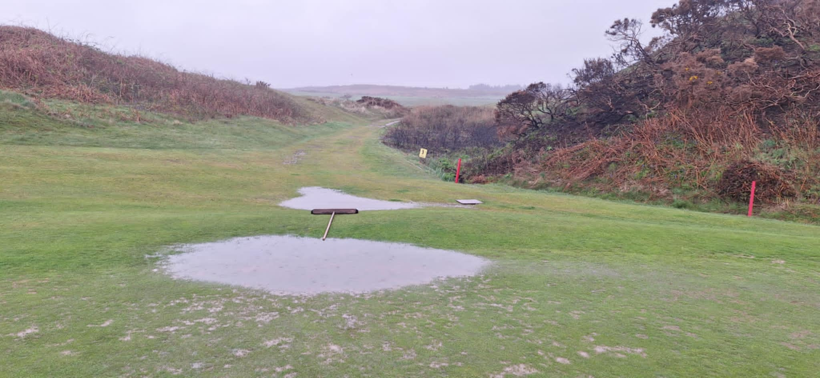
Taking advantage of dry weather on Tuesday, we prepared a significant amount of sand/soil mix for divot repairs. It's remarkable how quickly this mixture is depleted with daily tee divoting.
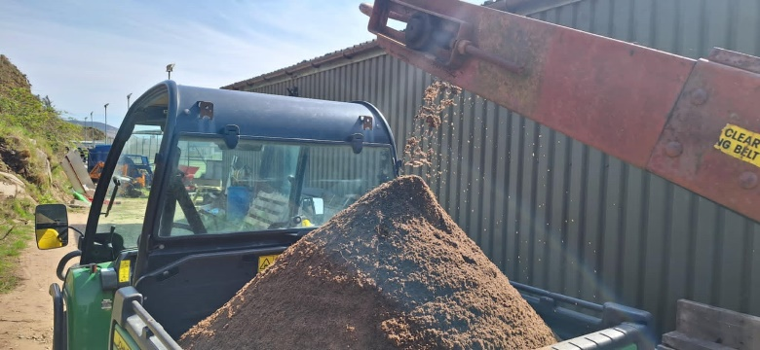
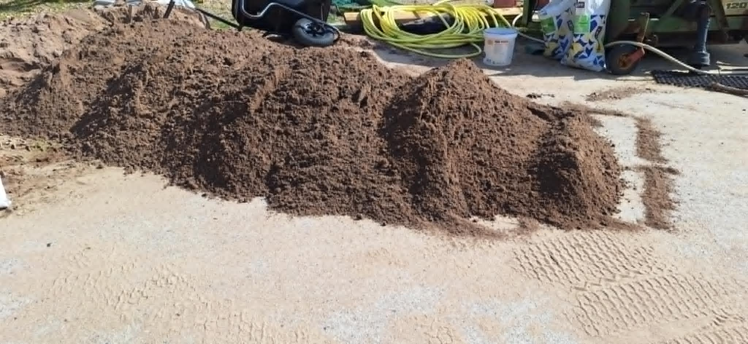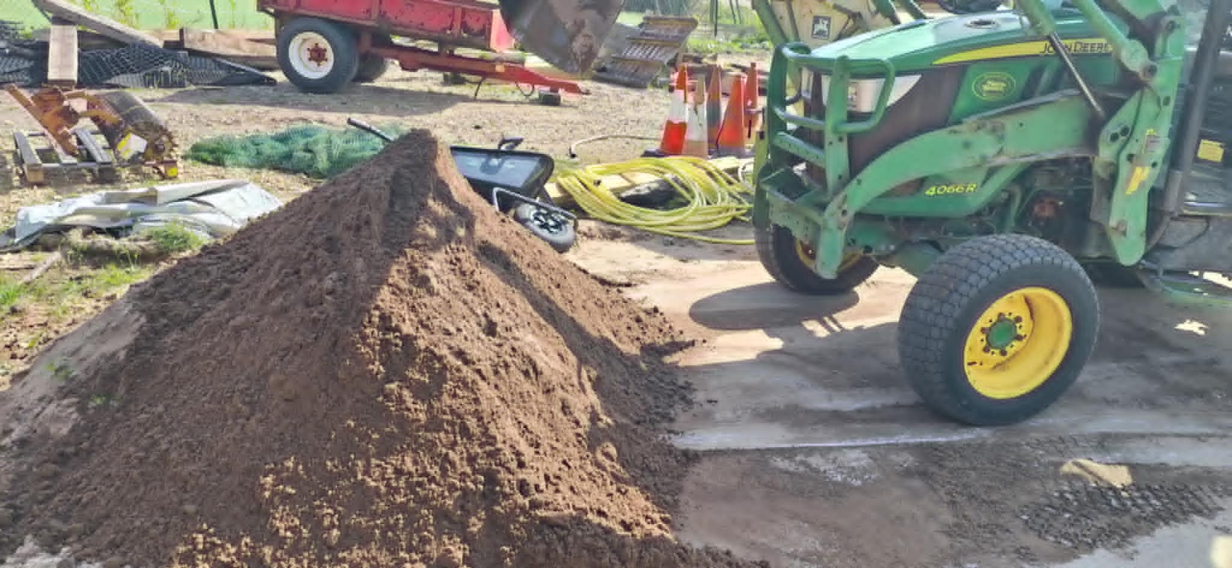

The 3rd green received another round of overseeding and top dressing.
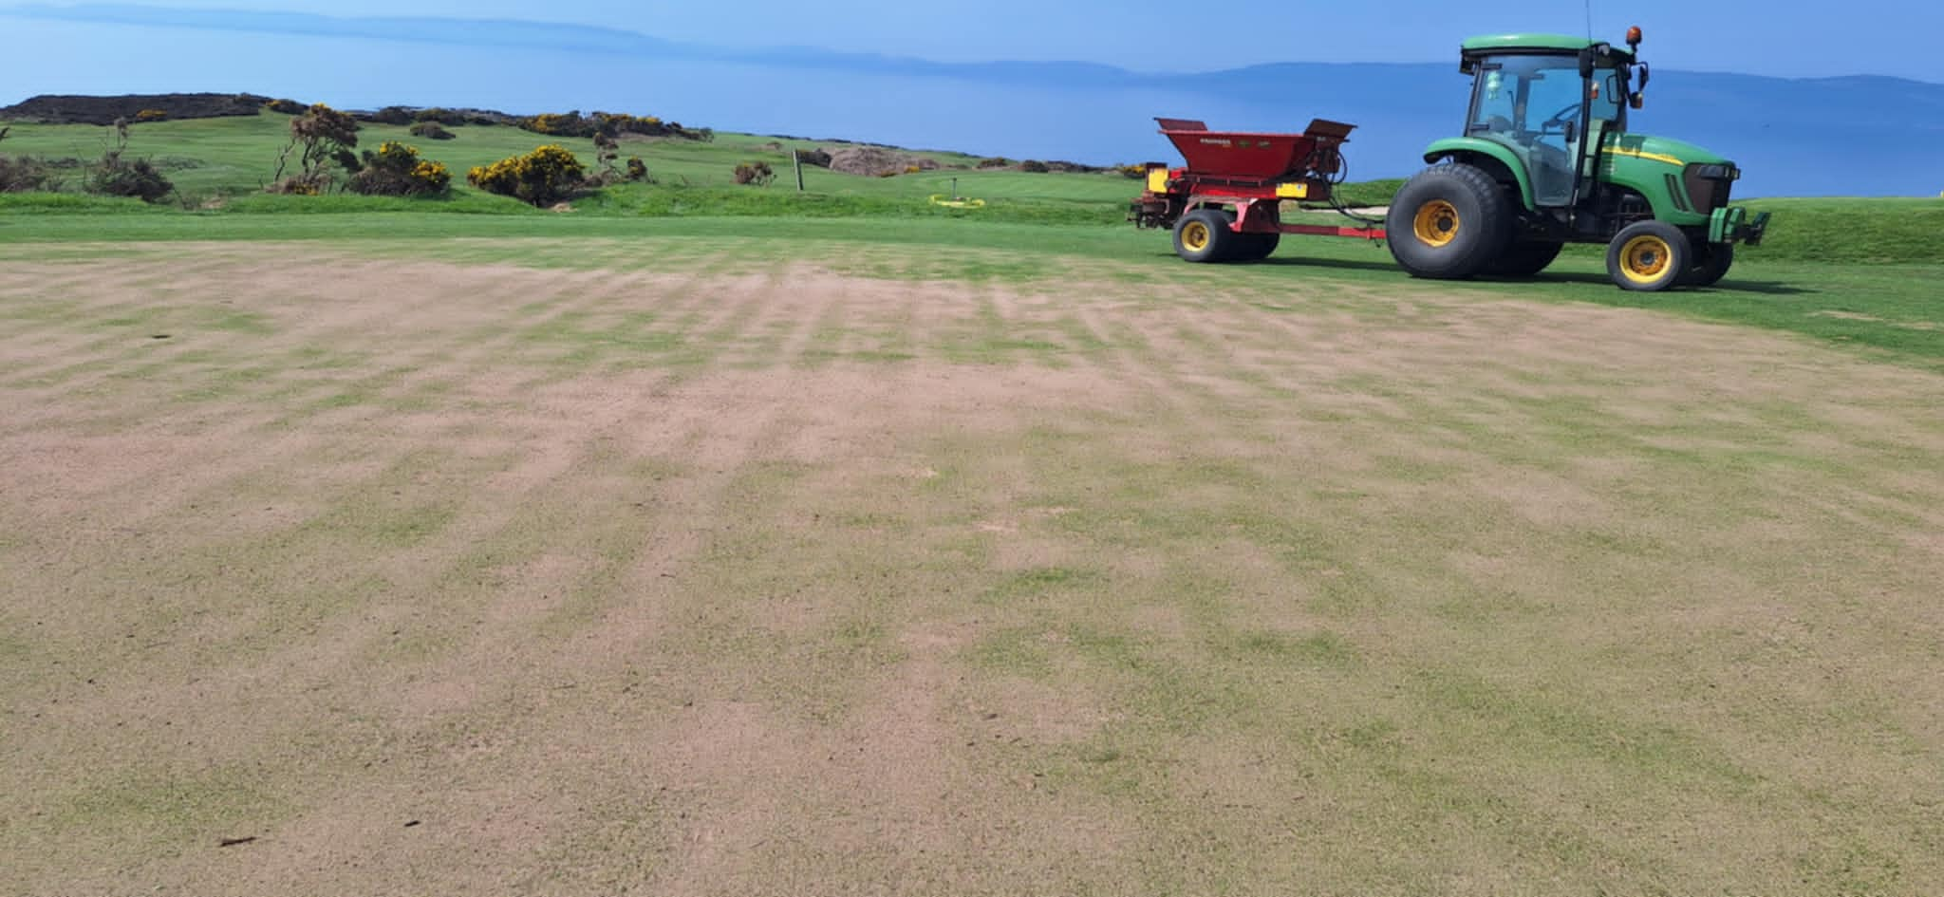
The course is now showing improved definition, thanks to the welcome rise in temperatures. This week, the fairways and semi-rough were cut twice, and the greens were both hand-cut and mowed twice. Additionally, we overseeded the weaker areas on the 5th and 6th greens, and the burn crossing over the 9th was thoroughly tidied up.




